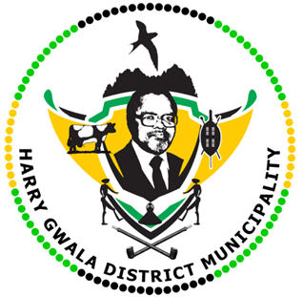
HARRY GWALA DISTRICT MUNICIPALITY
“Together We Deliver and Grow”
OFFICE OF THE MUNICIPAL MANAGER
40 Main Street, Private Bag X501, IXOPO 3276
Tel: (039) 834 8754 Fax: (039) 834 1701
Email: mbanjwas@harrygwaladm.gov.za

07 July 2022

A dignified send off for Mandisa Sebenza.

The late Mrs Mandisa “Nomama” Sebenza (49), an employee of the Harry Gwala District Municipality, was described as a humble, hardworking and humorous person who was full of jokes.
Sebenza who worked as a Disaster Officer, passed away after a short illness on the 1st on July, she will be buried on the 9th of July in Chamto Location (UMzimkhulu).
A memorial service was held in her honour at Peace Initiative Hall in Ixopo today (07 July 2022).
Harry Gwala District Speaker Cllr. Sibongiseni Mdunge, addressing the mourners during the memorial service, he sent condolences to the Sebenza family and assured them that the municipal leadership was mourning with them during the difficult time.
“When we lose employees, it simply means that service delivery is affected, because we will be having more workload and less manpower. Although we are mourning, we are consoled by the fact that Sebenza worked for our municipality with pride and dedication. We pray that God gives you strength during this difficult time.” Said Speaker Mdunge.
Also attending the memorial service was Umzimkhulu Mayor, Cllr. Jabulile Msiya, who also described Sebenza as a humble and a hard worker who will be missed by many.
The 1st National deputy President of the South African Municipal Workers Union (SAMWU), Mr. Mluleki Mbhele addressing mourners, he said he was proud of the calibre of an employee she was.
Sharing the same sentiment, Acting Municipal Manager, Mrs Thobile Thiyane-Magaqa, said there had lost a dedicated individual.
“She was humble and had a sense of humour. We as the municipality are finding it hard to deal with her immediate death, her chapter is closed but in our heart it will never be closed,” said Mrs Thiyane-Magaqa.
Mourners included Harry Gwala District Municipal workers, workers from other municipalities, family, friends who packed the Peace Initiative Hall to bid her farewell. She is survived by her husband and three children.

ISSUED BY HARRY GWALA DISTRICT MUNICIPALITY COMMUNICATIONS UNIT.

